EU MARE NOSTRUM | BENEFICIARY GUIDE

INDEX

- NOTE FROM THE COORDINATING INSTITUTION…………………………… | 3
- WHERE YOU CAN FIND DOCUMENTS………………………………………….… | 3
- NEXT STEPS…………………………………………………………………………..……… | 4
- BEFORE YOUR ARRIVAL…………….……………………………………….…… | 4
- Letter of Acceptance ………….………………..………………………………. | 4
- Travel form ……….…………….…………….……….……………………….….. | 5
- Compulsory Documents ……………………..…………………………….…. | 5
- Letter of invitation………………..…………..….………………………….…. | 6
- Getting your VISA…………………………………..…………………………..… | 6
- AT YOUR ARRIVAL…………………………………………………………………… | 6
- Confirmation of arrival……….……………………………………….… | 6
- Learning agreement……………………………………………………….… | 6

- NOTE FROM THE COORDINATING INSTITUTION: “The University of Murcia”
On behalf of the EU MARE NOSTRUM project, the University of Murcia, as coordinating institution of the project, would like to congratulate you for having been awarded an Erasmus Mundus scholarship.
The aim of this handbook is to offer useful information about the subsequent steps you need to follow and complete the documents that you will need in order to prepare your stay.
- WHERE YOU CAN FIND DOCUMENTS
Once the scholarship has been awarded to you, your status will change from “applicant” to “beneficiary” and you will be able to enter the online application through “Restricted Area: Beneficiaries”.
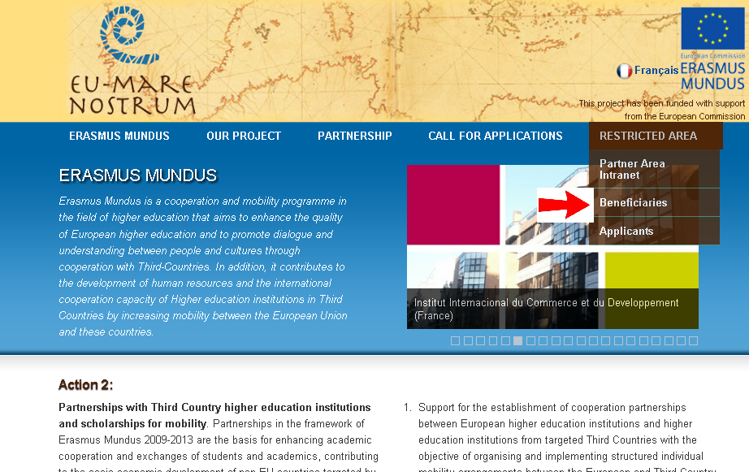

In that personal area the documents will be available to you by clicking on “Documents”. The documents may change or be uploaded during the process, so you should check your e-mail frequently in case there is any new document as the coordinators will let you know.
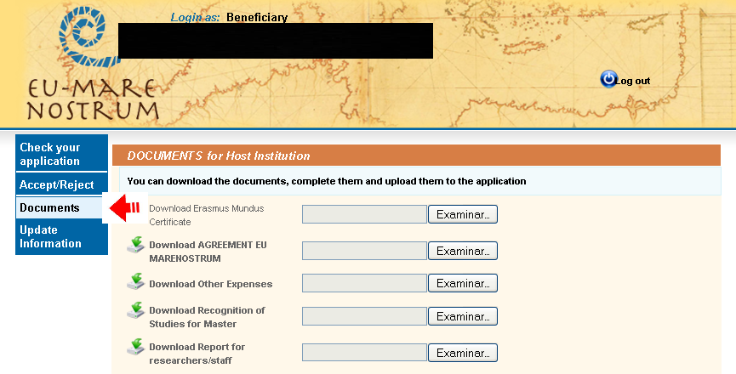
- NEXT STEPS
In this section you will find information about the next steps you have to follow once you have been awarded the scholarship. In order to facilitate the process, we have organized the process chronologically, that is to say, following the natural steps you will follow. They are divided into steps necessary before your arrival and those necessary at your arrival.
  - BEFORE YOUR ARRIVAL:
- “Letter of Acceptance”: The first thing that you have to do is accept the scholarship in the website. You should go to the area of “Beneficiaries” and click on “Accept/Reject”.
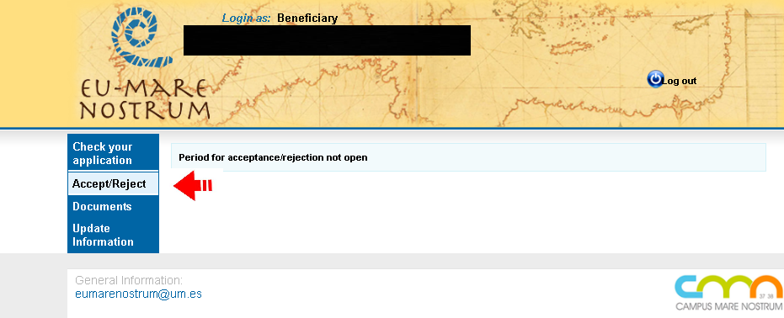
There you will find a document called “Letter of Acceptance” that you need to download and sign. Then you have to upload a scanned copy of the same document on the platform.

- “Travel form”: You have to proceed with the travel arrangements. The University of Murcia, as coordinating institution will arrange your travel. You need to contact the travel agency and provide the document “Travel form” which you will find in the area of “Beneficiaries”. Once you have completed the document, you have to send it, with a copy of the passport, to universidaddemurcia@viajeseci.es .
The program will arrange your flight and cover the expense; however, you may have to face other travel expenses (bus or train to the airport, taxis, rent car etc.) Once you arrive to your host institution you will be able to claim back these expenses. For that reason, please keep each ticket or invoice of payment to properly document the cost of the travel. You will find a document called “Other Expenses” in your beneficiary area to claim the expenses back.
- Compulsory Documents: Go to the area of “Beneficiaries” on the website and find:
  - “Erasmus Mundus Certificate”: this document identifies you as an Erasmus Mundus Beneficiary, and should always have it with you.
  - “Student Agreement Erasmus”: this is a very important document. Please download it and read it carefully.
The agreement needs to be signed by all parts (first beneficiary, then home university and then host university). Finally, you should send a paper copy by ordinary mail to:
Universidad de Murcia
Servicio de Relaciones Internacionales
Edif. Rector Soler. Campus de Espinardo
30071 Murcia (España)

  - Health Insurance: the program will guarantee you health insurance coverage during your stay abroad. Once you are awarded the scholarship, you are registered with our Insurance Company and receive an insurance card upon arrival from your host university coordinator. Your complete policy is available on the website. Please fill it in with your personal data, print your copy and take it with you at every moment in case you may need it.
“Letter of invitation”: To get your letter of invitation, you should contact the responsible person at your host university. You can find the “contact person” of each university here:
https://eumarenostrum.um.es/eumarenostrum/eumarenostrum.public.europeanpartners.do?idioma=l001
- Getting your VISA: It is essential that you start soon the process of getting your VISA. Based on the previous experience of Erasmus Mundus students, visa issues demand much time and attention. For a more effective result, please start with the visa paperwork as soon as possible and be very concentrated when you prepare the documents for visas.
As a rule, to apply for a visa you need:
  - Valid passport
  - Letter of invitation from the host university.
  - Ticket
  - Medical Insurance
  - Filled in application form (with the indication of your future address or address of the university and contact person there).

  - AT YOUR ARRIVAL
- “Confirmation of arrival”: you will find this document in the area of “Beneficiaries”. As soon as you have arrived at your host university, and have met the staff at the International Office or your academic advisor, please have it signed and sent by fax to University of Murcia, EUMN. 00 34 868 88 4130.
Deadline to receive the “Confirmation of arrival” is December 20th. 2014.
- Recognition of Studies. In your beneficiary area you will find the necessary documents to arrange in advance your recognition of studies both with home and host institutions.
For undergraduates: prior to your departure fill in the LEARNING AGREEMENT.
Once you have finished your studies fill in the TRANSCRIPT OF RECORDS and upload it to the website.
For Master scholarships: fill in the PROPOSED PROGRAMME OF STUDY FOR MASTER. Once you have finished, please upload your TRANSCRIPT OF RECORDS.
For the rest of levels: PhD, Post-doc and Staff, they should complete the INITIAL and FINAL REPORT FOR RESEARCHERS/STAFF.
All these documents are a guarantee for your recognition of studies. You should arrange it with your corresponding academic advisors and have it signed by all parts. At the end of your stay you will have to fill in the FINAL QUESTIONNAIRE FORM in order to check your academic progress.

We must remind you that according to article 3 of the agreement signed, it is compulsory to complete the period of studies/research. Otherwise, the payment of the grant will be subject to reimbursement.

Further informations at eumarenostrum.um.es.

